**What is HTML?**

HTML (Hyper Text Mark-up Language) is basically a standard mark-up language used to create websites and webpages. It describes how the structure of a webpage is going to look like and comprises of different elements:

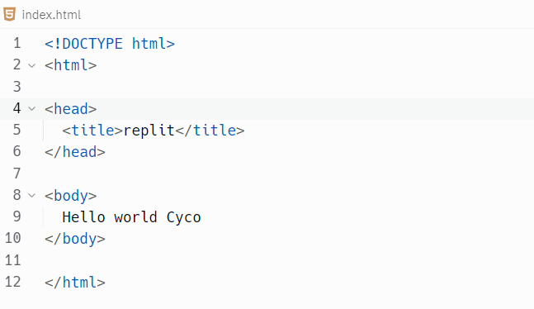

* The ***<!DOCTYPE html>*** tag in the above screenshot is a declaration that defines the document is an html document.
* The ***<html>*** tags contains everything that will be coded for our webpages.
* The ***<head>*** tags contains some information about the top of webpages.
* The ***<title>*** tags are used to define the name of a tab and must be under the ***<head>*** element.
* The <***body>*** tags contains everything that appears within the body of the webpage.

Webpages also consist of ***<h1, h2…h6></h1, h2...h6>*** tags that specify sizes of heading texts within webpages. Then there’s also ***<p></p>*** tags that are used to specify paragraphs or plain text in a webpage. Webpages also contain ***Link*** tags that help you jump from one webpage/ section to another by clicking on it through the use of ***<a></a>*** tags that contain attributes:

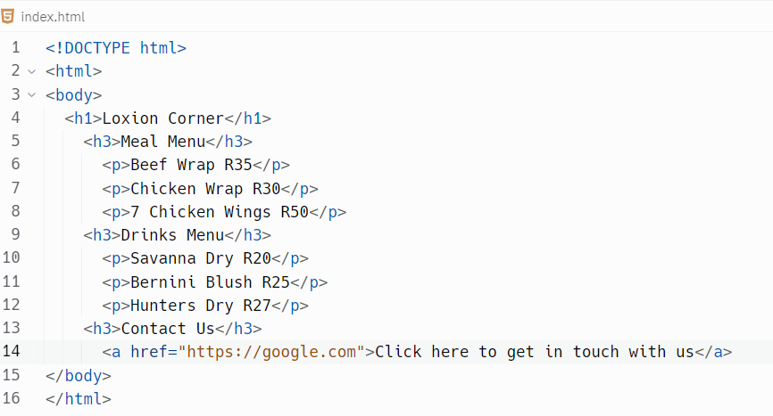

* The use of the ***href*** attribute helps define the link destination address of a webpage/ section.
* The ***target=”_blank”*** attribute is used to open link on a new tab.

There’s also an ***<img>*** tag that allows the webpage to display an image. This doesn’t have a closing tag; it uses a ***src*** attribute to assign the image address/ link. It also uses ***height*** and ***width*** attributes to adjust image size as shown below:

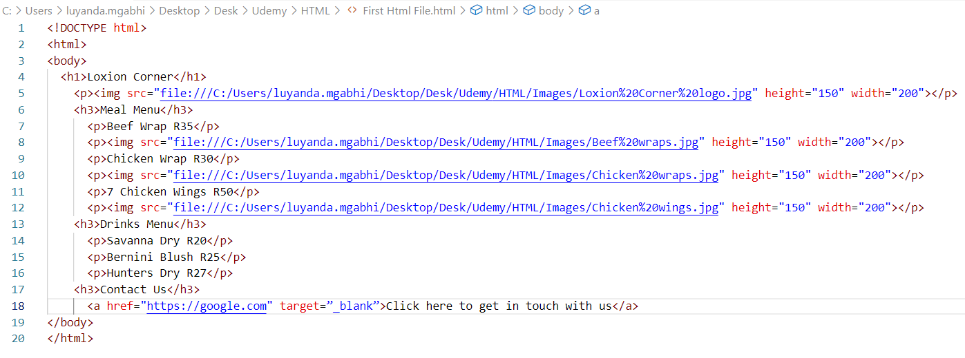

A ***break <br>*** tag is used to jump to the next line of a paragraph in webpage:

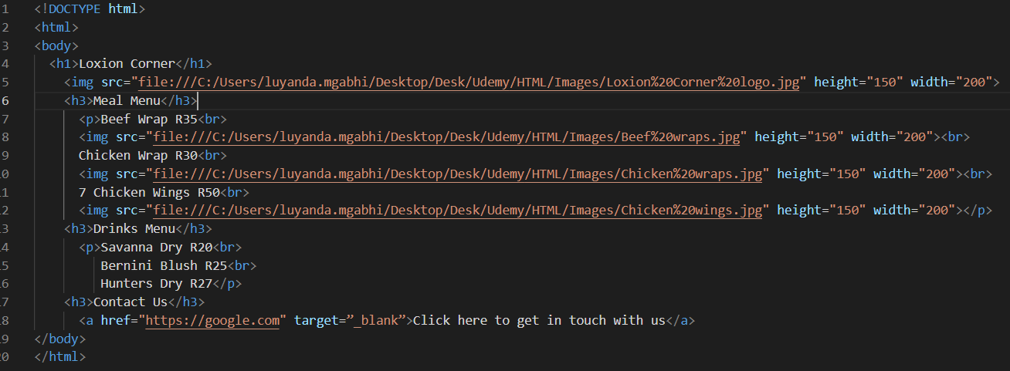

***<pre></pre>*** tags are also used to display multiple paragraph lines:

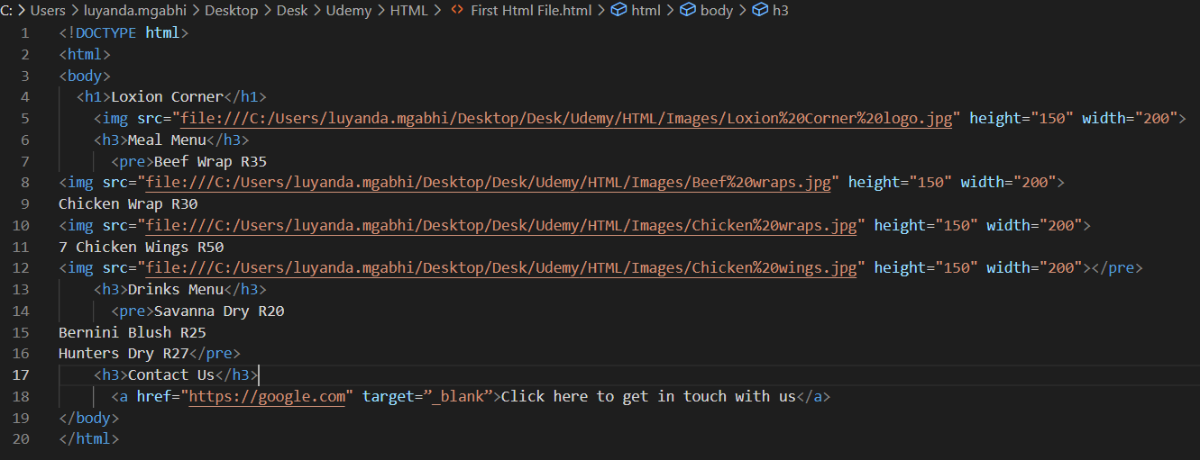

***<hr>*** tag is used to create lines in between paragraph lines:

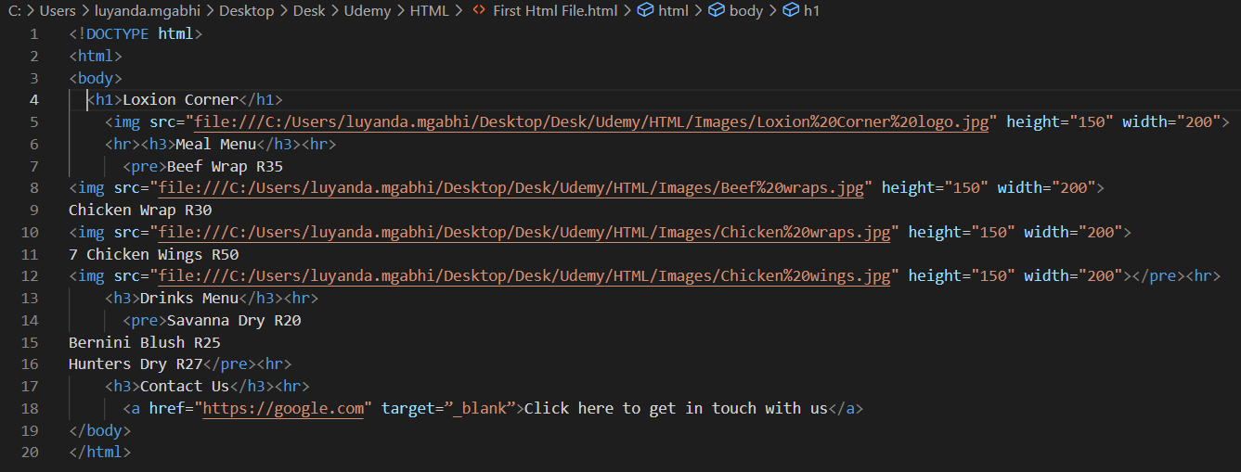

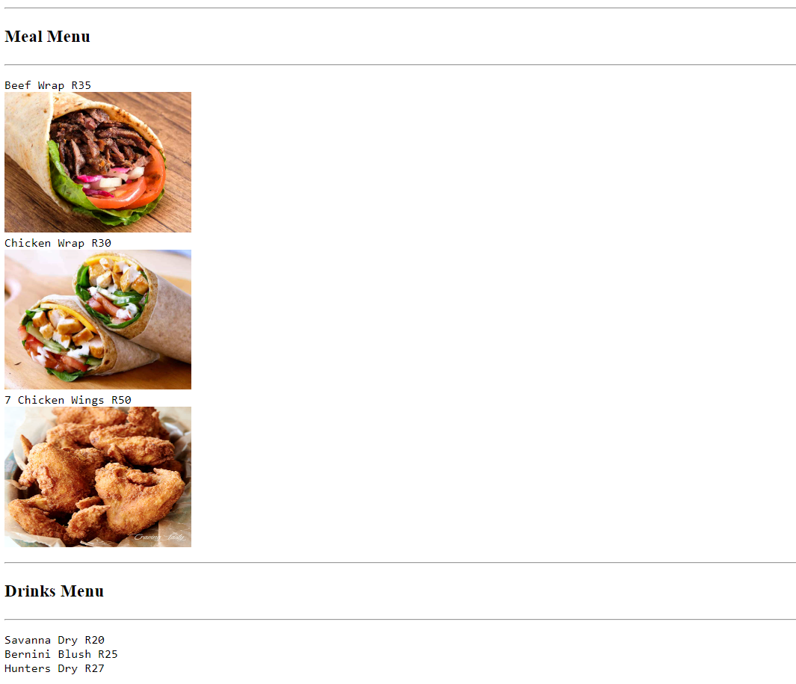

To format text different tags are used for example to make text bold, ***<b></b> or <strong></strong>*** tags are used.

Also ***<em></em> or <i></i>*** tags are used for italic or emphasized text

***<mark></mark>*** tags are used to highlight text.

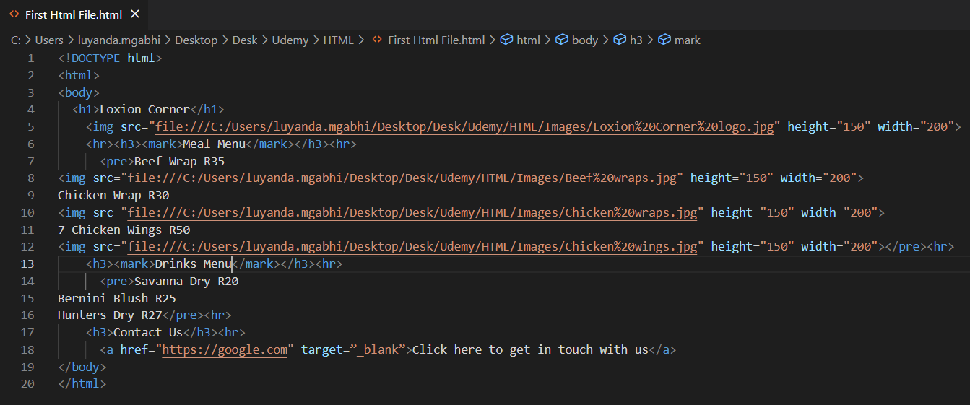

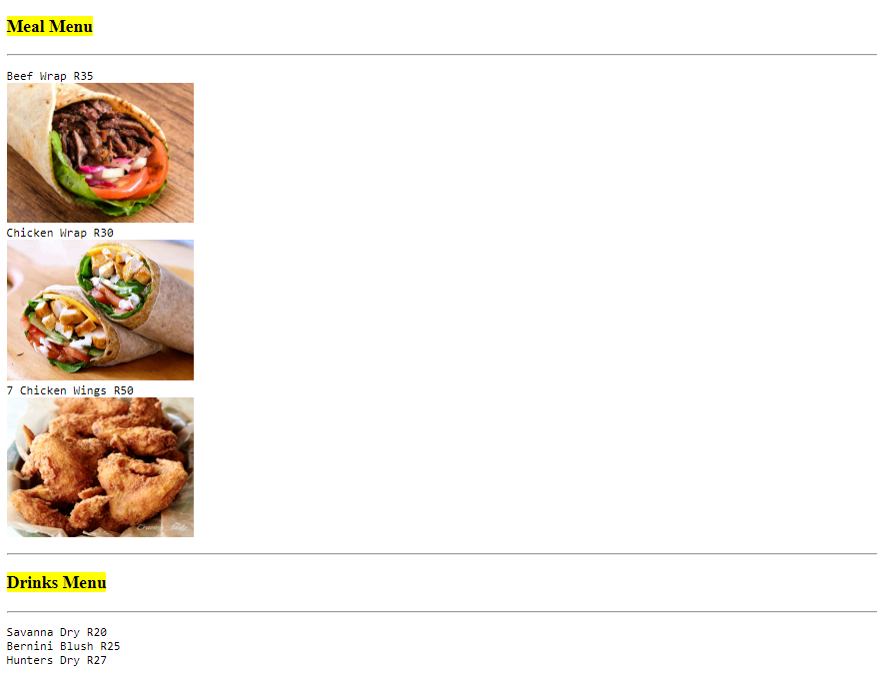

A ***<del></del>*** tags are used to strike off text as shown below:

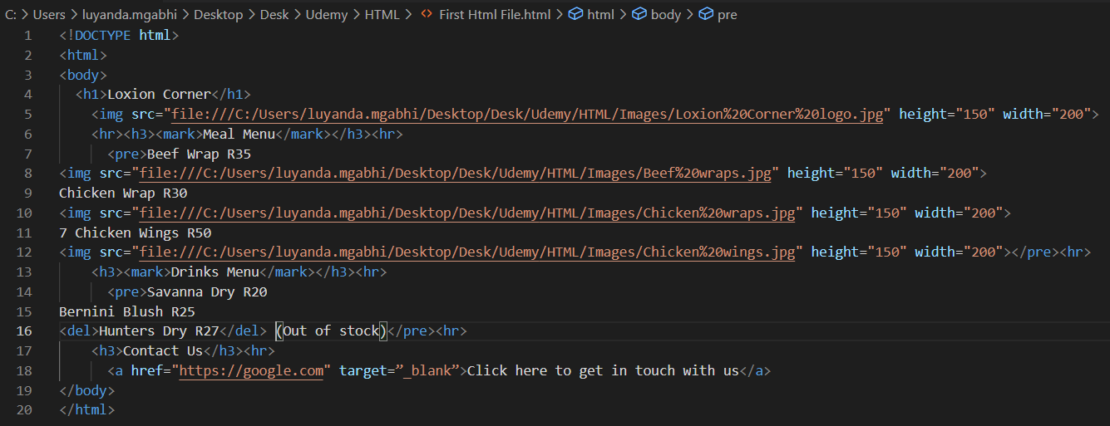

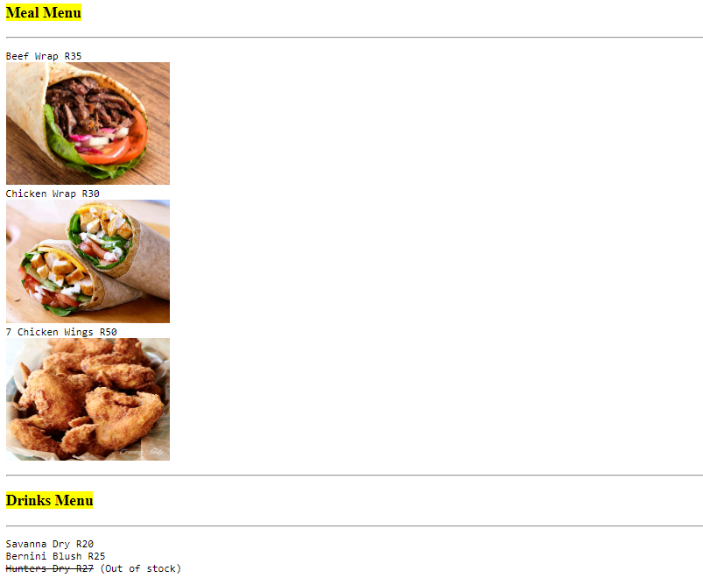

The ***<ins></ins>*** tags are used to underline text.

The ***<small></small>*** tags are used to display really small text sizes.

The ***<sub></sub>*** tags are used to subscript text, for example O2.

The ***<sup></sup>*** tags are used to superscript text, for example 23 = 8

The ***style=””*** attribute is used to describe the colour of an element like text colour.

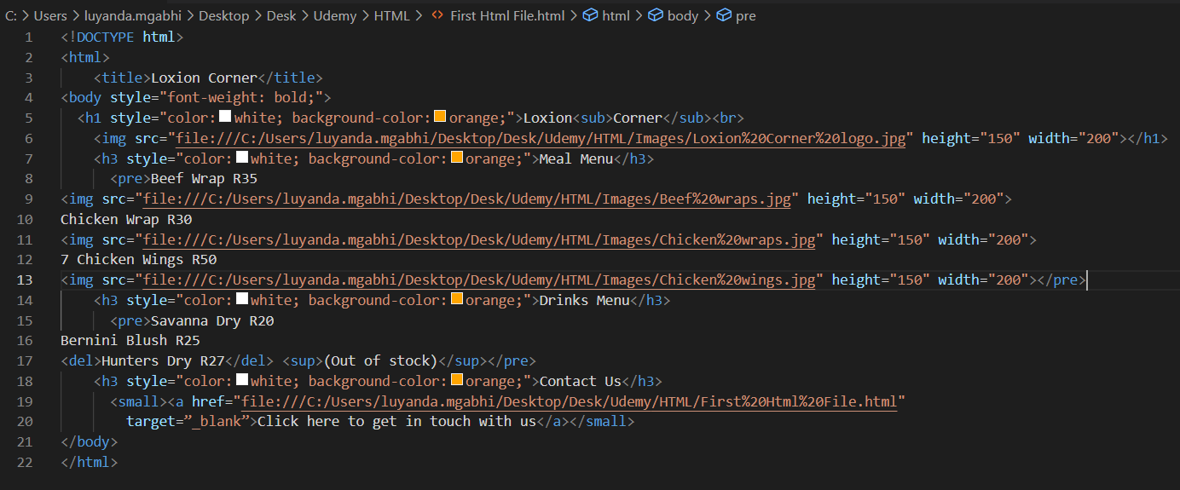

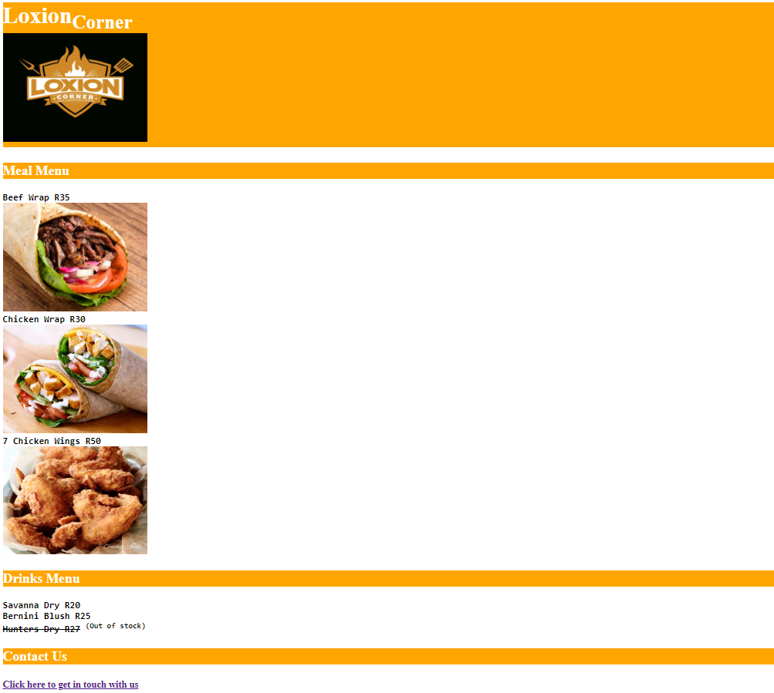

To comment on html code, ***<!--comment -->*** is used.

A ***relative URL*** is used to link to a section within a local website/ webpage, for example ***<a href=”google.com”></a>*** is a relative URL.

An absolute URL is used to link to an external and not local website/ webpage, for example ***<a href=”***[***https://google.com***](https://google.com)***”></a***> is an absolute URL.

The ***favicon*** of a webpage is represented by a logo next to the ***<title>*** of a webpage. Both the ***<title>*** and ***favicon*** should be defined under the ***<head>*** element. A ***<link>*** tag with ***rel=”icon”*** and ***href=”icon address”*** attributes are used to display the title logo/ favicon.

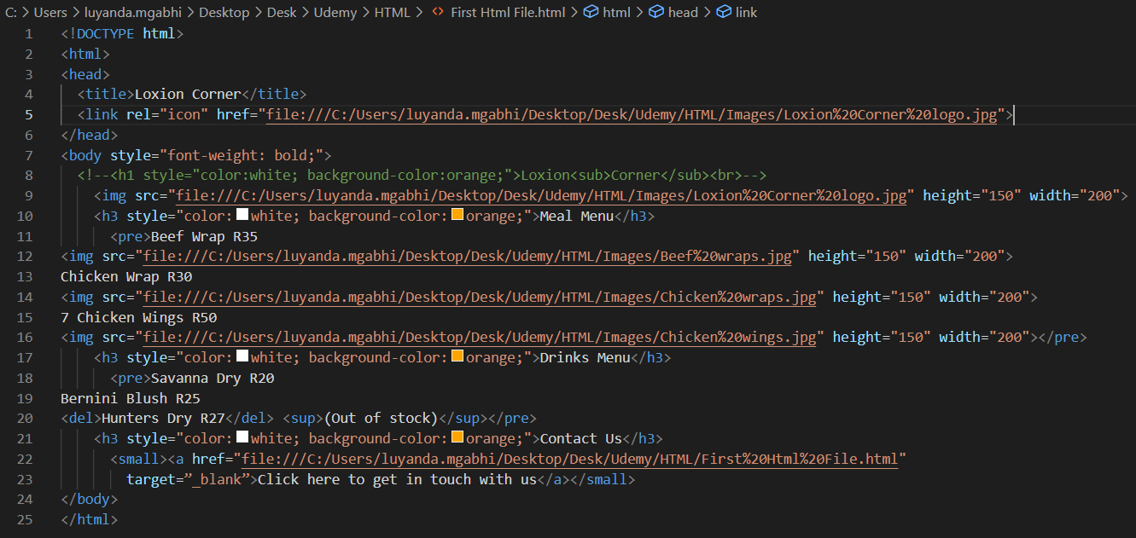

The ***<table></table>*** element is used to create table on webpages.

* The ***<tr></tr>*** tags are used to add table rows.
* The ***<th></th>*** tags are used to add table headings.
* The ***<td></td>*** tags are used to represent table data.
* The ***<ul><li></li></ul>*** tags are used for unordered list.
* The ***<ol><li></li></ol>*** tags are used for ordered list.
* The ***<dl><dt><dd></dd></dt></dl>*** tags are used for a description list.

***Block*** element are those that contain other elements like the ***<div></div>*** element which is used to separate different sections of a webpage.

***Inline*** elements are those that are contained within block elements like the <a> and <b></b> tags.

An Iframe is used to show a webpage inside a webpage.

* <iframe src=”https://google.com”></iframe>

To add ***copyright*** sign to a webpage, the ***&#169*** is used.

***Forms*** are a way you can collect input from an end user.

* A ***<form></form>*** tag is used for the above.
* An <***input>*** element is used to specify the type data being collected from the form.
* The ***<input>*** element collects various attributes but the most important being the ***type=””*** attribute that shows what type of data is being collected.
* Examples of types of input include ***text, password, number, checkbox, radio buttons***, etc.
* ***<input>*** elements are represented as empty bars.
* The ***name=””*** and ***id=””*** attributes also required to process the input data at the backend.
* The ***value=””*** attribute is used in association with a ***checkbox*** and ***radio button*** type of input.
* So whenever a checkbox is ticked, it is the value and not the label object that is fed into the backend for processing.
* The form also consists of a ***<label></label>*** element which labels types of input.
* The ***for=””*** attribute is used within the label element to link it to its corresponding input.

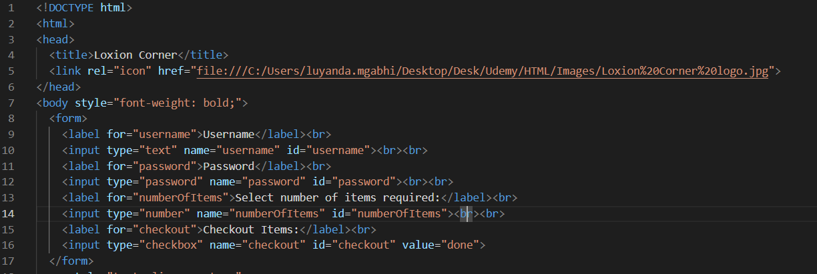

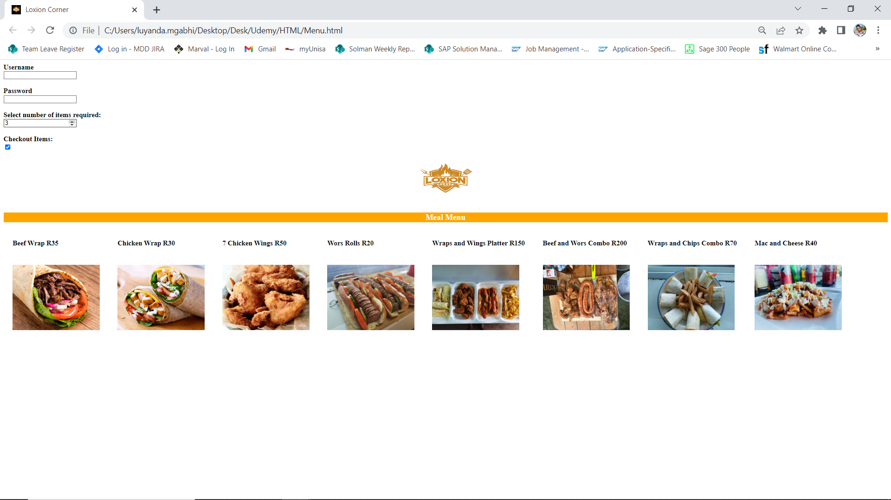

* An ***<input>*** element with the ***type=”submit”*** is used to add a button that will collect the end user data for backend processing.
* The ***value=””*** attribute within the input element is used to edit the button text.
* An ***action=””*** attribute within the <form> opening tag is used to specify the destination of the collected form data is being sent to, whether to another webpage called orderItems.
* Also the ***method=”GET/ POST”*** attribute is used to send the collected data, if this is not specified then HTML uses the GET method by default.
* The different between the two methods is that the GET method shows information being sent on the URL whereas the POST method doesn’t.

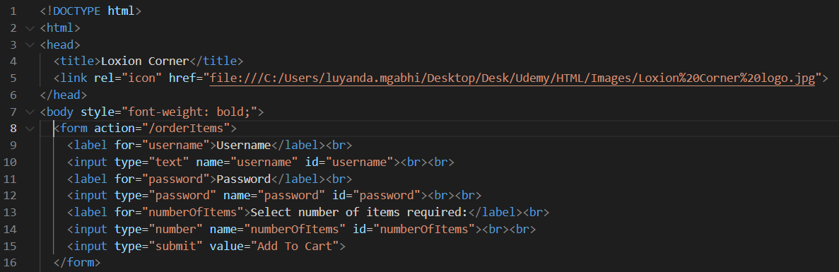

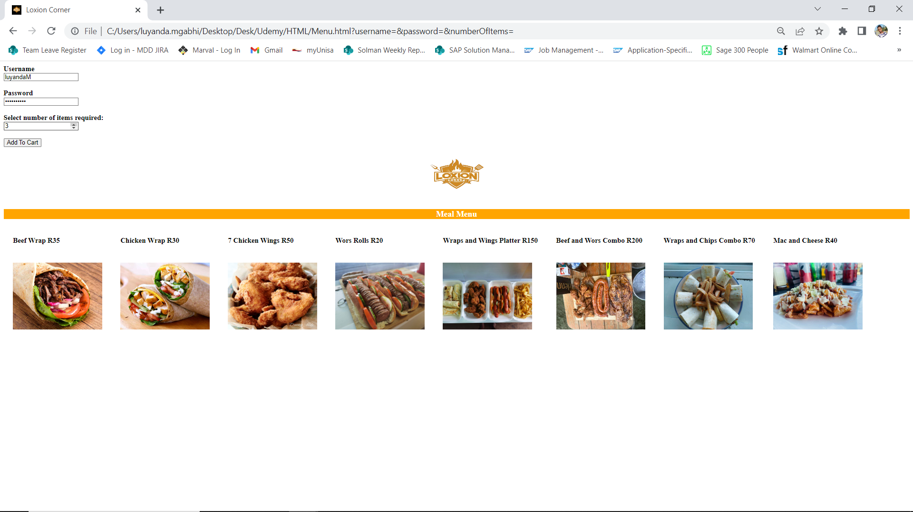

***Wire frame*** ***diagrams*** show the design or structure of a webpage.

***Site diagrams*** show the design of how all webpages of a website are structured and interact.

